PANEL REFERENCE | PPSHCC-55
DA NUMBER | DA2020/00641
LGA | Newcastle
PROPOSED DEVELOPMENT | Community Facility - Pathway - "Richmond Vale Rail Trail" – (RVRT)
STREET ADDRESS AND OWNER DETAILS | - Hunter Water Corporation – Lot 1 DP 805274- 81 King St Shortland  - Hunter Water Corporation – Lot 1 DP 611441- 83 King St Shortland  - Hunter Water Corporation – Lot 2 DP 611518 – 4A Anderson Drive, Tarro  - Hunter Water Corporation – Lot 148 DP 840897 – 29 Woodford St Minmi  - Hunter Water Corporation – Lot 147 DP 1143414 – 292A Minmi Rd Fletcher  - National Parks & Wildlife Service – Lot 3-4 DP 171105 50A Sparke St Hexham  - Department of Lands – Lot 1 DP90465 12A Railway St Hexham  - Minister Administering the National Parks & Wildlife Act 1974 – Lot 1 DP 1007615 33 Lenaghans Drive Minmi  - Coal & Allied Operations P/L – Lot 10 DP1194449 67C Maitland Road Hexham  - Coal & Allied Operations P/L – Lot 1 DP877233 52A Lenaghans Drive Minmi  - Minister Administering the National Parks & Wildlife Act 1974 – Lot 21 DP1195619 52A Lenaghans Drive, Minmi  - City of Newcastle – Lot 324 DP 1175558 50 Kural Crescent Fletcher
APPLICANT | City of Newcastle (CN)
DATE OF DA LODGEMENT | 23 June 2020
RECOMMENDATION | Approval

Background
The subject application ((DA2020/00641) for a Community Facility – Pathway, known as the 'Richmond Vale Rail Trail (RVRT)' was reported to the Hunter Central Coast Regional Planning Panel (HCCRPP) for determination on 10 November 2020.
This supplementary memo provides further information in response to matters raised during the determination meeting and provides associated amended conditions of consent. A 'track changes' version of the amended conditions is provided at Attachment A. A 'clean' copy of the amended conditions for inclusion by the HCCRPP in the determination have been provided at Attachment B.

State Environmental Planning Policy (Coastal Management) 2018

State Environmental Planning Policy (Coastal Management) 2018 (CM SEPP) aims to protect and manage the New South Wales coast and foreshores and requires the consideration of specific criteria based on the type of coastal area affected.

As outlined within the 'Council Assessment Report' the proposed development constitutes designated development subject to cl.10(2) of the CM SEPP and is in proximity to coastal wetlands. As such, the provisions of the CM SEPP apply, the development application has been assessed against the mandatory pre-conditions of consent and is determined to be satisfactory:

Clause 5 – Land to which the policy applies – The CM SEPP applies to land the whole or any part of which is within the ‘coastal zone’. The majority of the subject site is mapped as falling within several categories of the coastal zone as defined under Clause 6, as follows:

- Coastal Wetlands (the majority of the proposal is affected except for the last several kilometres to Minmi & adjacent the Aurizon lands at Hexham)
- Coastal Wetlands Proximity Area (due to the amount of Coast Wetlands affected there are also further portions in this respect affected)
- Coastal Use Area (the areas of the proposed cycleway from Shortland toward the north west to Fishery Creek falls into this category)
- Coastal Environment Area - (the areas of the proposed cycleway from Shortland toward the north west just beyond Fishery Creek falls into this category)

Clause 10 - Development on certain land within coastal wetlands and littoral rainforests area: Clause 10 requires development consent for certain works including earthworks and any other development, and as such applies to the proposed development. It is noted that Clause 10(2) provides that the subject development constitutes designated development. The application has been assessed as designated development.

It is noted that cl.10(6) of SEPP CM provides that cl.10 does not apply to the carrying out of development on land reserved under the National Parks and Wildlife Act 1974 where the proposed development is consistent with a plan of management prepared under that Act for the land concerned. Hunter Wetland National Park Plan of Management (POM) was adopted 23 March 2020, prior to the development application's lodgment 23 June 2020, however this was not addressed in the Applicants submission which was prepared prior to the adoption of the POM.

It is noted that the POM identifies the component of the cycleway proposed within the Hunter Wetland National Park. As such, development consent is not required for this leg of the cycleway and this part of the proposal is to be removed from the application by way of conditions of consent. This matter is discussed in further detail below under the discussion of the E1 zone.

Clause 11 – Development on land in proximity to coastal wetlands or littoral rainforest: Clause 11 provides that development consent must not be granted to development on land identified as 'proximity area of coastal wetlands' or 'proximity area for littoral rainforest' unless that the consent authority is satisfied that the proposed development will not significantly impact on a) the biophysical, hydrological or ecological integrity of the adjacent coastal wetland or littoral rainforest, or b) the quantity and quality of surface and ground water flows to and from the adjacent coastal wetland or littoral rainforest.

The subject site is predominately mapped as coastal wetlands with coastal wetland proximity area directly adjacent. In terms of the land on which the cycleway is proposed, it located on historic man-made embankment previously used as railway line and water pipeline and constitutes highly disturbed lands. Furthermore, it is also notable that in terms of the areas associated with the proposed cycleway, there is little difference between the areas mapped as coastal wetlands and those as coastal wetlands proximity area in terms of the physical traits and characteristics (although the adjacent lands, outside the area of the current proposal, does vary).

As detailed within the assessment of the main report, the cycleway, including the bridges, culverts, and boardwalk sections from Minmi Junction to Fletcher have been designed so to not alter the water flows within the wetland and estuarine environments both in terms of flow velocity and volumes. It is further noted that conditions have been recommended as part of the original report requiring that further detailed design analysis of flooding effects is undertaken at the Construction Certificate stage to ensure that no net changes result from the current proposal.

Clause 12 – Coastal vulnerability area: The proposal does not affect any Coastal Vulnerability Area

Clause 13 - Development on land within the coastal environment area : Clause 13 provides that development consent must not be granted to development on land that is within the coastal environment area unless the consent authority is satisfied that the proposed development will not cause an adverse impact on: the integrity and resilience of the biophysical, ecological and hydrological environment, including surface and groundwater; coastal environmental values and processes; water quality of any sensitive coastal lakes; marine vegetation, native vegetation and fauna and their habitats; existing public open space and access to and along the foreshore; and Aboriginal cultural heritage.

The development is located upon highly disturbed land and predominately within an existing man-made embankment, the detailed 'Council Assessment Report' concludes that are no likely impacts to this environment, particularly in relation to the biophysical environment and coastal processes and maintaining public access to the foreshore.

The proposal would have no material impact on environmental, coastal, native vegetation, surf zone or access issues listed above. Similarly, the long historic usage of the site as a railway corridor, and its highly disturbed nature. The proposal has been assessed in terms of Aboriginal heritage including archaeological aspects. There are two areas which may be affected but these are not listed archaeological sites. Conditions have been recommended requiring application to Heritage NSW for Section 140 Excavation Permit. Overall, the proposal is acceptable, on balance, in terms of its impacts.

Clause 14 - Development on land within the coastal use area - Clause 14 specifies that development consent must not be granted to development on land within the coastal use area unless the consent authority has considered whether the proposal is likely to have an adverse impact on existing, safe access to foreshore, beach, headland or rock platform by the public (including those with a disability); overshadowing, wind funnelling, loss of views, visual amenity and scenic quality of the coast, aboriginal cultural heritage and cultural/built heritage; and that the consent authority is satisfied the proposal is designed such to avoid these adverse impacts or is otherwise managed to minimise the impacts.

The proposal improves and increases the safe access to the 'foreshore areas' adjacent coastal wetlands inclusive of disabled access. The development is not otherwise in the vicinity of beaches, headlands, or rock platforms. Considerable design development was undertaken to improve access within the amended proposal and ensure disabled access was achieved especially at the Minmi and Shortland trailheads.

The development involves limited and otherwise very low scale structures with the majority of the proposal involving at grade cycleway and associated fencing. The proposed bridges, culverts, amenities buildings, rest and shelter area structures will not cause any adverse impacts in terms of overshadowing. Similarly, the proposal will have negligible impacts in terms of wind funnelling and otherwise will maintain the status quo in terms of the existing man made embankments.

The proposal will not result in the loss of views and the developments visual amenity and scenic quality impacts have been assessed and are acceptable. Specifically, the profile of the track and associated ramping to bridges/culverts has been minimised as much as possible to limit the impacts on visual appearance both in the natural coastal context and also the heritage significance.

The heritage aspects of the proposal, both in terms of Aboriginal and European heritage and culture, has been considered in depth as part of the heritage assessment under Clause 5.10 of the NLEP 2012 and it has been demonstrated that the proposal does not have any unreasonable impacts. Therefore, the proposal acceptable having regards to the provisions of Clause 14 of SEPP CM and development consent can be granted.

Clause 15 - Development in coastal zone generally – development not to increase risk of coastal hazards: Clause 15 specifies that development consent must not be granted to development on land within the coastal zone unless the consent authority is satisfied that the proposed development is not likely to cause increased risk of coastal hazards on that land or other land. A detailed assessment of the proposal has been completed as detailed within the 'Council Assessment Report' and it has been determined that the development will not cause increased risk of coastal hazards.

Clause 16 - Development in coastal zone generally – coastal management programs to be considered: Clause 16 prescribes that development consent must not be granted to development on land within the coastal zone unless the consent authority has taken into consideration the relevant provisions of any certified coastal management program that applies to the land. There are no applicable coastal management programs which apply to the subject site.

The proposed development has been assessed having regard to the objectives and pre-conditions contained within the CM SEPP and subject to the amended recommended conditions of consent contained at Attachment B is considered satisfactory.

State Environmental Planning Policy (Koala Habitat Protection) 2019 and State Environmental Planning Policy (Koala Habitat Protection) 2021

The Council Assessment Report referenced State Environmental Planning Policy No.44 – Koala Habitat Protection ('SEPP No.44'), however SEPP No.44 was repealed by cl.18 of the State Environmental Planning Policy (Koala Habitat Protection) 2019 ('Koala SEPP 2019') with effect from 1 March 2020. The development application was lodged on 23 June 2020. The application has been further assessed having regard to the 'Koala SEPP 2019' provisions.

It is advised that the Koala SEPP 2019 was amended several times prior to it later being repealed by State Environmental Planning Policy (Koala Habitat Protection) 2020 and State Environmental Planning Policy (Koala Habitat Protection) 2021. It is further advised that State Environmental Planning Policy (Koala Habitat Protection) 2020 has not no effect on the current proposal as it only applies to RU1, RU2 and RU3 zoned lands.

Similarly, State Environmental Planning Policy (Koala Habitat Protection) 2021 ('Koala SEPP 2021'), was made and commenced on 17 March 2021. While this SEPP applies to the Newcastle Local Government Area under Clause 6(1) and Schedule 1, has no application due to the effect of Clause 18 Existing development applications, which provides that this SEPP does not apply to any applications lodged, but not determined, by the time the SEPP commenced.
Koala SEPP 2019 aims to encourage the proper conservation and management of areas of natural vegetation that provide habitat for koalas to ensure a permanent free-living population over their present range and reverse the current trend of koala population decline.

The development site spans multiple land zonings including 'R2 – Low Density Residential, E1 – National Parks and Nature Reserves, E2 – Environmental Conservation, E3 – Environmental Management, E4 – Environmental Living, and SP2 – Infrastructure (Sydney Newcastle Freeway)'.

Clause 8 - Development assessment process— approved koala plan of management for land. There are no approved koala plans of management applying to the land.

Clause 9 - Development assessment process—no approved koala plan of management for land. Clause 9 provides for the assessment of applications where they are identified on a Koala Development Application Map, there is no approved koala plans of management and the area of effect is at least 1 hectare, which is the case in this application. The subject site is not located within a Koala Development Application Map area.

Clause 10 - Development assessment process—other land. Consent under Clause may be given where the land is not identified within Koala Development Application Map, does not have an applicable approved koala plan of management for land and does not constitute land that is core koala habitat. The proposed cycleway does not trigger any of these criteria and, as such, the application could be determined in accordance with Clause 10.

Overall, it is advised that the area affected by the current proposal site does not contain sufficient native vegetation to qualify as koala habitat. In addition, no evidence of resident koala population was found within the area of the proposal. Accordingly, the proposed development is acceptable in terms of the provisions of Koala SEPP 2019.

Newcastle Local Environmental Plan 2012 (NLEP2012) – E1 Zone/ CM SEPP/ Clause 5.10

Portions of the development site as zoned 'E1 Zone – National Parks and Nature Reserves' under NLEP2012. Under the 'E1 Zone' uses authorised under the 'National Parks and Wildlife Act 1974' (NPW Act) are identified as permitted without consent. It is noted that within the land use table for the 'E1 Zone' development permitted with consent is listed as 'Nil'.

Section 151A of the NPW Act specifies purposes for which a lease of licence may be granted on reserved land (other than nature reserve) and includes at subclause 1(a)(iii) for general purposes 'to enable activities of a recreational, educational, or cultural nature to be carried out and the provision of facilities for that purpose'.

There is no other part of the NPW Act, or National Parks and Wildlife Regulation 2019, which identifies or details 'uses authorised' under the Act. As such, the purposes contained under s.151A are taken to be the relevant 'uses authorised' for the purposes of the E1 Zone. The NPWS has confirmed that an application is required to be made to NPWS under s151 to allow the development to proceed. An appropriate condition of consent in this respect has been recommended as part of the original 'Council Assessment Report'.

Whilst the proposed development is permitted without consent in the E1 Zone, and would ordinarily require assessment under Part 5 of the EP&A Act, development consent is required under Part 4 of the EPA Act, for several of the legs of the cycleway which are zoned E1 National Parks and Nature Reserves. The permissibility of the E1 zoned components and associated requirements for development consent of the cycleway have been outlined below:

- Shortland to Hexham Junction (historic Chichester pipeline – 'southern leg')

The E1 zone within the Shortland to Hexham Junction leg of the proposed cycleway (see Figure 1 below) is entirely affected by Clause 10 coastal wetlands of the SEPP CM as shown within Figure A below. Clause 10(1) of SEPP CM provides that development consent is required for clearing or native vegetation, marine vegetation, earthworks, constructing a levee, draining of land and 'any other development'. The RVRT cycleway development constitutes 'any other development' and includes proposed 'earthworks'.

Figure 1 - Aerial Photograph of Site/SEPP (Coastal Management) 2018/Locational Map
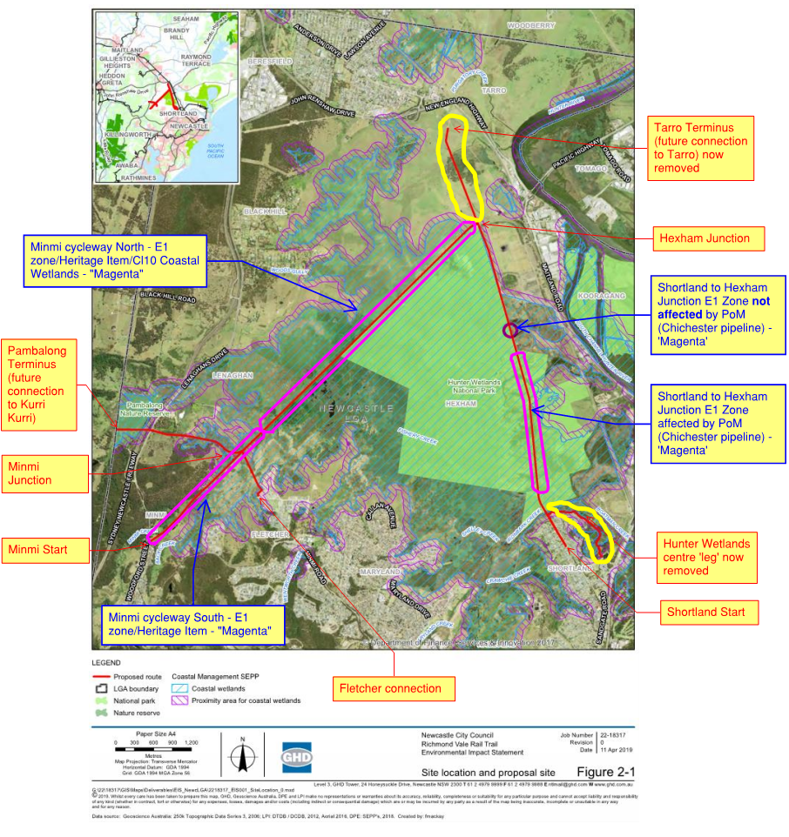
Source: Extracted from GHD EIS Oct 2019, with notes added.

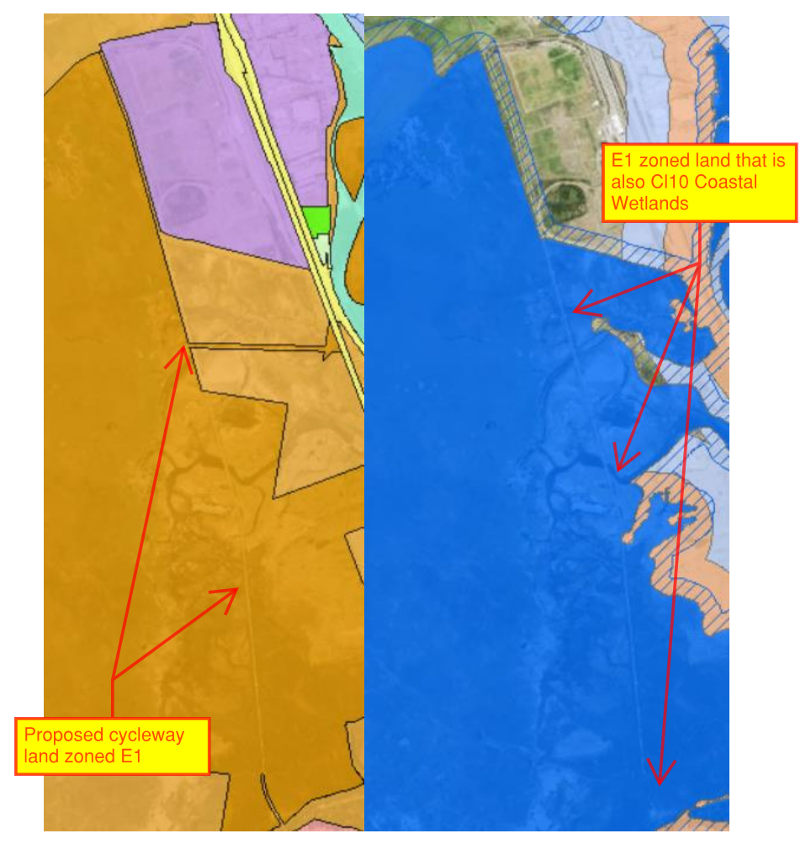
Figure A – Side by comparison of E1 zoned lands and Clause 10 Coastal Wetlands.

In this regard, the requirement to obtain development consent under cl.10(1) is inconsistent with the land use table for the E1 Zone under NLEP2012 which identifies development permitted with consent as 'nil'. However, clause 7 of SEPP CM specifies that 'in the event of an inconsistency between SEPP CM and another environmental planning instrument, whether made before or after the commencement of the SEPP, the SEPP prevails to the extent of the inconsistency'. As such, the provisions of cl.10(1) of SEPP CM prevail in relation to the elements of the proposal located within the Shortland to Hexham Junction.

However, cl.10(6) of SEPP CM provides that cl.10 does not apply to the carrying out of development on land reserved under the National Parks and Wildlife Act 1974 where the proposed development is consistent with a plan of management prepared under that Act for the land concerned. The Hunter Wetland National Park Plan of Management (POM) was adopted 23 March 2020 (see Figure B below) and addresses this element of the cycleway. The cycleway is considered consistent with the adopted POM.

As a result, this part of the cycleway, does not require development consent under Part 4, and instead requires separate approval under Part 5 of the Environmental Planning and Assessment Act 1979 (EPA Act). Notwithstanding, this assessment has comprehensively addressed and assessed the environmental issues associated with overall proposed cycleway inclusive of the portions which are considered to fall under Part 5 of EPA Act.

The Applicant has confirmed that they agree to this matter to be addressed by conditions of consent inclusive of the removal from the proposal those portions for which Part 4 consent is not required. Amended conditions of consent are to be provided to address and marked up plans have been prepared to clearly identify the extend of the approval under this application.

Figure B – Hunter Wetlands National Park Plan of Management shown in green (Note: that the POM does not apply outside the green area and the affected cycleway is shown by black dashes within the POM).
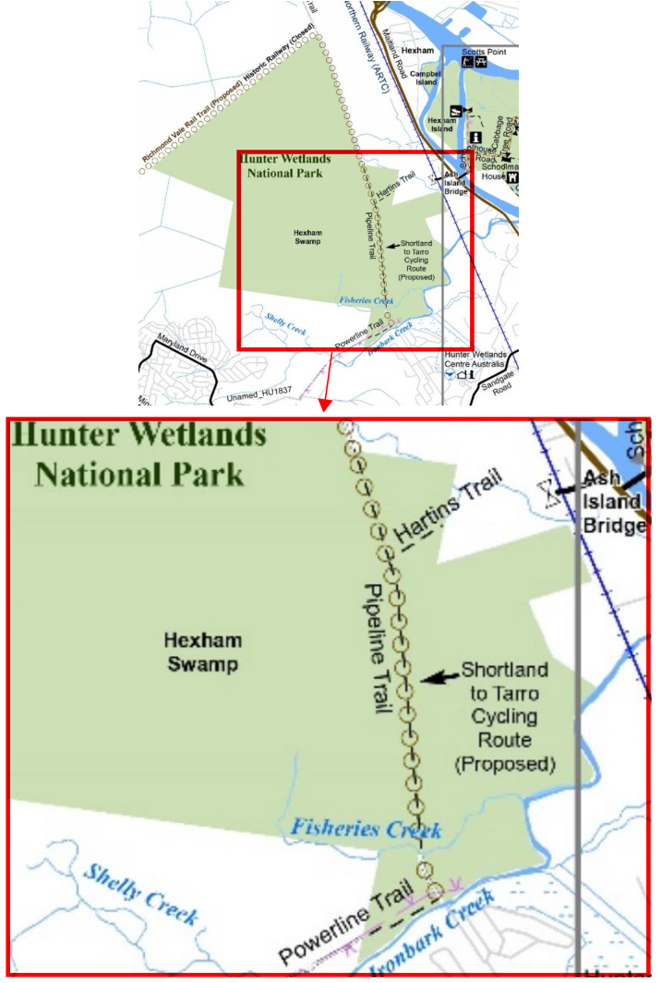

- Shortland to Hexham Junction (mid point 'circle')

There is a small portion of E1 zone within the Shortland to Hexham Junction leg of the proposed cycleway (see Figure 1 above extracted from 'Council Assessment Report') which is affected by Clause 10 coastal wetlands of the SEPP CM as shown within Figure A below but is not covered by the Hunter Wetlands National Park Plan of Management (NB: this area is represented by the smaller circle on Figure 1 in comparison to the area of the POM under Figure B).

As this small area is not affected by the POM, it is confirmed that Clause 10(1) of SEPP CM continues to apply (Cl 10(6) is not applicable) and provides that development consent is required for clearing or native vegetation, marine vegetation, earthworks, constructing a levee, draining of land and 'any other development'. The RVRT cycleway development constitutes 'any other development' and includes proposed 'earthworks'.

In this regard, the requirement to obtain development consent is inconsistent with the land use table for the E1 Zone under NLEP2012 which identifies development permitted with consent as 'nil'. However, clause 7 of SEPP CM specifies that 'in the event of an inconsistency between SEPP CM and another environmental planning instrument, whether made before or after the commencement of the SEPP, the SEPP prevails to the extent of the inconsistency'. As such, the provisions of cl.10(1) of SEPP CM prevail in relation to the elements of the proposal located within the Shortland to Hexham Junction. Accordingly, development consent is required, and can be granted, for this component of the development.

- Minmi to Hexham Junction (historic Richmond Vale railway line) – Southwest

The southwestern portion of the Minmi to Hexham Junction leg of the proposed cycleway (see Figure 1 above extracted from 'Council Assessment Report'), which is also zoned E1 under the NLEP, is not affected by Clause 10 coastal wetlands of the SEPP CM (refer Figure C below).

However, unlike the Shortland to Hexham Junction leg (outlined above), the entirety of the Minmi to Hexham Junction leg is mapped a listed heritage item under sch. 5 of the NLEP2012 (Figure C). Accordingly, this element of the development is subject to the provisions of cl.5.10(2)(a)(i) of NLEP2012 which provides that development consent is required for demolishing, moving, or altering a heritage item. The proposal involves works which demolish, remove and/or relocate existing heritage fabric (e.g. historic rail lines and sleepers) and this requires consent under Cl 5.10(2). As such, whilst the Shortland to Hexham Junction leg of the proposal is zoned E1, development consent requirements are triggered subject to cl.5.10 of NLEP2012.

- Minmi to Hexham Junction (historic Richmond Vale railway line) – Northeast

The north-eastern portion of the Minmi to Hexham Junction leg, is also zoned E1 National Parks and Nature Reserves (see Figure 1 above extracted from 'Council Assessment Report'). This component of the development is affected by both Clause 10 of the SEPP CM being coastal wetlands, and cl.5.10 of NLEP2012 a listed heritage item. As discussed above, due to the application of cl.5.10 NLEP, the development requires consent under Part 4 of the EPA Act.
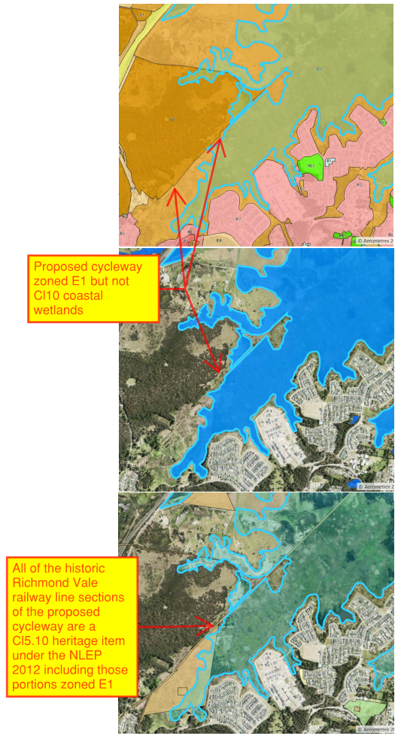
Figure C - E1 zone compared to Cl10 coastal wetlands and Cl5.10 NLEP 2012 heritage item

Owner's consent

The proposed cycleway application (DA2020/00641) was lodged under the provisions of Clause 49(2) of the Environmental Planning and Assessment Regulation 2000, as extracted below.

Clause 49(2) EP&A Regs allows for a development application, made by a public authority, which the City of Newcastle constitutes, to be made without the consent of the owner of the land. To rely on Clause 49(2) the applicant must meet one of two prerequisites. In this instance, the City of Newcastle gave notice to the various landowners of the proposed application prior to the lodgement of the said development application.

It is further advised that during the assessment of the application the proposal's reliance on the use of Cl49(2) EP&A Regs was queried and further clarification sought from the applicants. In response to the request for further information regarding the ownership and Cl49(2) EP&A Regs, the applicants submitted evidence of written notification of all of the landowners prior to the lodgement of the application on 23 June 2020.

The following owners were contacted:

- Crown Lands,
- Hunter Wetlands Centre,
- Hunter Water Corporation,
- National Parks and Wildlife Service (Minister for Energy & Environment),
- Yancoal (Coal and Allied).

The terms of Clause 49(2) EP&A Regs have been demonstrated to be satisfied.

Aurizon access arrangements

Aurizon had made written objections to the proposal and then further made presentations at the public hearing for the proposal on the 10 November 2021.

A number of concerns were raised by Aurizon, as detailed below, which were partly addressed within the original 'Council Assessment Report' and are further discussed below for clarity: -

- Cycleway terminus towards Tarro impacting on Aurizon lands – The proposed cycleway from Hexham Junction to the 'Tarro terminus' has been removed from the amended development application. The removal of this aspect from the amended application resolves this concern regarding the cycleway ending near Aurizon access roads and potential conflict with cycleway users in an isolated terminus location.

- Concern regarding the potential conflicts with Aurizon lands – Conditions have been recommended addressing i) fencing so to restrict access to Aurizon's site (condition 30 originally) and ii) that no works, stockpiles etc be undertaken on any Aurizon's lands. It is advised that use of existing access roads for construction access is not restricted but would be subject to securing agreements for access in this respect.

- Potential to conflict with existing access arrangements – Aurizon had raised concerns that the proposal, and especially construction works/access, could conflict with pre-existing conditions placed on Aurizon's consent not to restrict access to any third parties (notably on the western side of the cycleway). Aurizon were not able at the hearing or in separate discussions with the applicants, to clarify the nature of this condition.

In terms of land owners on the 'western side' of the cycleway, there is none which are not already involved as part of the application (i.e. no private land ownings). It is noted that there was a property to the northwest of Hexham Junction which appears to enjoy access over the cycleway portion now removed following amendments to the application (i.e. Hexham Junction to Tarro leg).

It is proposed to impose a condition restricting the construction and operation cycleway from impacting on any existing access conditions which Aurizon must meet. It is further advised that only construction access is likely to have any potential impacts and this access would be subject to Aurizon's prior agreement in any respect.

- Lack of consultation by applicants – Further discussions have been undertaken with the applicant regarding the extent and nature of discussions with Aurizon to date. The applicant has agreed that while additional consultations could have occurred, they've noted that until the applicant had planning consent there was little certainty regarding the project. More so, that the funding and commencement of project would allow considerable time to finalise any necessary access agreements.

It is further noted that the applicants are confident that the construction access could occur without any notable impact on Aurizon's operations. Additionally, it is noted that the applicants have indicated that, if construction access could not be achieved via Aurizon's lands, the construction of the project could still be achieved via Minmi and access along the cycleway route.

Additional proposed conditions:

- No works, stockpiles, portable sheds, or the like (temporary or otherwise) are to occur on lands owned by Aurizon Operations Limited (Lot 104 & 105 DP 1189565, Lot 1 DP 155530) or lands owned by R D Smith (Lot 312 DP 583724). This limitation is inclusive of locations shown as chainages between 3500-5350 (as follows 3500, 3600, 4200, 5300 & 5350).

Note: This condition does not any on affect use of existing access roads for construction vehicles where agreements with existing land owners are secured.

- The construction and operation of the proposed cycleway at any time contravene any pre-existing access conditions imposed on Aurizon's operations under their approval (MP07_0171 – dated 10 October 2013).

Remediation assessment and conditions ('Cap and contain' vs. 'Off-site removal')

The following condition is recommended to be imposed so to resolve and questions regarding the intended remediation approach for the proposed cycleway application: -

- Any remediation of contamination required to satisfy human health and ecological assessment criteria is to be achieved by removal of material off-site and disposal at an appropriately licenced facility only. Under no circumstances are capping or other remediation methods that would require on-site management and/or implementation of a long-term environmental management plan to be used.

Conditions

In addition to the conditions above, and the minor formatting amendments provided directly to the draft conditions, the following additional matters were addressed within the revised conditions:

- Condition confirming the correct intended position of the amenities block (plan C1100 vs D1004)
- Condition addressing emergency access to the 'back gate' of the Hunter Wetland Centre
- Condition requiring the part of the cycleway which does not require development consent under Part 4, and instead requires separate approval under Part 5 of the Environmental Planning and Assessment Act 1979 (EPA Act), being removed from the proposal.

Conclusion

The above supplementary report, in combination with the revisions to the draft conditions by the Regional Planning Panel and the City of Newcastle, comprehensively addresses the concerns and issues arising from the determination meeting.

It is recommended that the application be supported on the combined basis of the 'Council Assessment Report' and this Supplementary report subject to the revised draft conditions of consent.

Attachment A – Amended conditions – 'tracked changes'
Attachment B – Amended conditions of consent

